C프로그래밍 실습

**#9 Structure**

* An Example of Structure

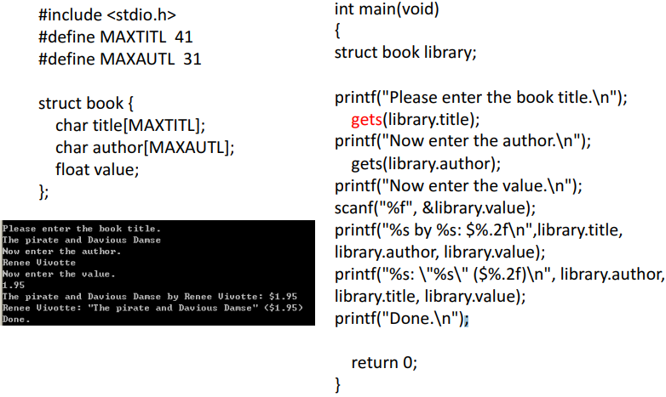

* Struct book library[20];

